***E-Fixed Deposits***

***Project Task: 1 (This is on the Business Analysis concepts taught)***

***Identifying Stakeholders –*** Customer, Employee’s, Upper management, Lower management, Banking staff.

***Main features that need to be developed –***

1. The bank users can create a fixed deposit using their existing online banking account or through their existing mobile banking account.
2. Checklist or requirements for opening ABC Bank FD online are:

* A savings account with ABC Bank
* An online banking account
* A mobile banking account

1. User should be shown various FD rates.
2. There should be a fixed deposit calculator. The FD calculator will display the maturity amount.
3. In cases where a user has multiple bank accounts, he/she should be able to select which account to debit for the FD.
4. There should be an option to create Joint FDs. In this case the name of the other customer along with his/her SSN details should be taken.
5. Users should have an option to enter a *nominee*.
6. Once the FD is created. The user should be emailed a PDF copy of the FD.
7. The PDF copy of the FD generated should be reflected in the online banking account and mobile banking account as well.

***Write the in-scope and out-of-scope items for this software.***

***In-scope – Out-scope***

|  |  |
| --- | --- |
| * Only ABC bank customer can open FD account * Requirements for opening ABC Bank FD online are: * A savings account with ABC Bank * An online banking account * A mobile banking account | * Other bank customer can’t open FD account in ABC bank. * Without requirement can’t open the FD account. |

***Business requirements: –***

***Functional requirements –***

1.The bank users can create a fixed deposit using their existing online banking account or t through their existing mobile banking account.

2.Checklist or requirements for opening ABC Bank FD online are:

* A savings account with ABC Bank
* An online banking account
* A mobile banking account

3.User should be shown various FD rates.

4. There should be a fixed deposit calculator. The FD calculator will display the maturity amount.

5. In cases where a user has multiple bank accounts, he/she should be able to select which account to debit for the FD.

6.There should be an option to create Joint FDs. In this case the name of the other customer along with his/her SSN details should be taken.

7.Users should have an option to enter a *nominee*.

8.Once the FD is created. The user should be emailed a PDF copy of the FD.

9.The PDF copy of the FD generated should be reflected in the online banking account and mobile banking account as well.

***Nonfunctional requirements –***

* **Easy and less time-consuming**
* **Easy payment**
* **Easy renewal and closure**

**Project Task: 2 (This is on the agile scrum concepts taught)**

***User story 1 -***

**As a** order manager, **I want** ability to update and change the list **so that** the customer is able to get the list of product

Acceptance criteria –

* Register
* Enter detail
* OTP
* Employee id

***User story 2 -***

**As a** customer, **I want** ability to login and open **so that** I can open the FD account.

Acceptance criteria –

* Login
* Enter detail
* OTP

**Project Task: 3 (This is on the Tableau concepts taught)**

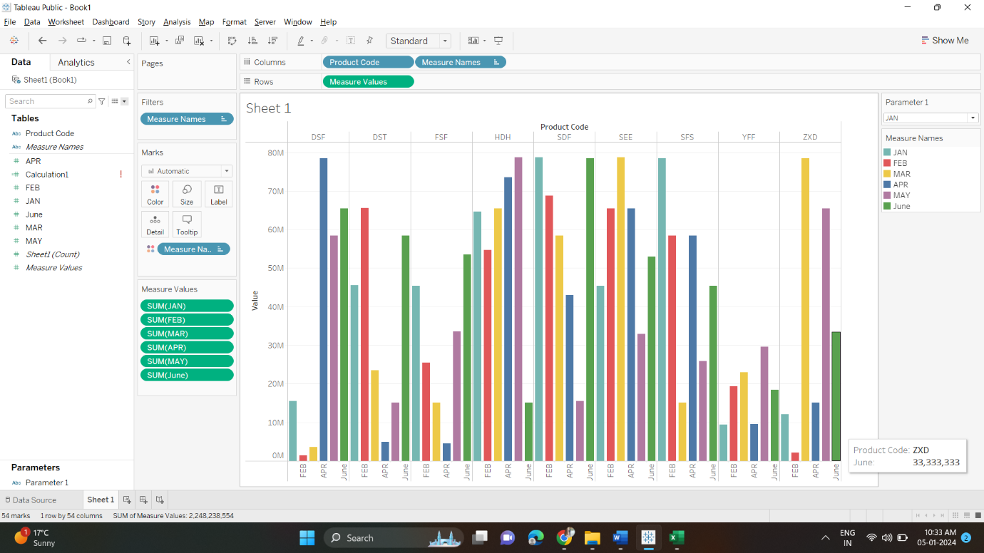

**Project Task: 4 Excel**

***Attached the file***